**Database and Management System Lab**

NAME: PRIYANSHI VARSHNEY

ROLL NO: R2142230042

SAP_ID: 500119947

BATCH 2

B.TECH CSE, SEM-III

**EXPERIMENT 11**

**Title: To understand the concepts of Index.**

**Objective:** Students will be able to implement the concept of index

**1. Create EMPLOYEES Table and Insert Sample Data**

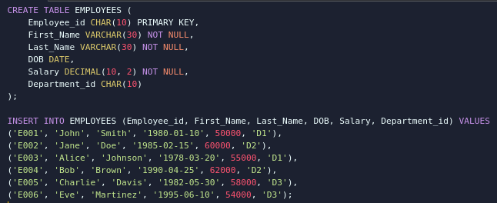

**2. Create an Index on Last_Name and Department_id**



**3. Find the ROWID and Create a Unique Index on Employee_id**



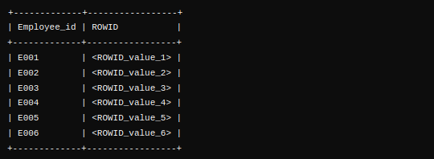

**4. Create a Reverse Index on Employee_id**



**5. Create a Unique Composite Index on Employee_id to Check Duplicates**



**6. Create Function-Based Index for Case-Insensitive Search on Last_Name**



**7. Drop the Function-Based Index on Last_Name**

